**DOCNEXUS**

**A PROJECT REPORT**

**for**

**Major Project (KCA353)**

**Session (2024-25)**

**Submitted by**

**MAYANK KUMAR 2300290140100**

**HARSH GUPTA 2300290140068**

**MANVI DAKSH 2300290140099**

**HARSH VERMA 2300290140070**

**Submitted in partial fulfilment of the**

**Requirements for the Degree of**

**MASTER OF COMPUTER APPLICATION**

**Under the Supervision of**

**Prof. R. N. Panda**



**Submitted to Department Of Computer Applications**

**KIET Group of Institutions, Ghaziabad**

**Uttar Pradesh-201206**

**(December 2024)**

### CERTIFICATE

Certified that **Mayank Kumar Roll No. 2300290140100, Harsh Gupta Roll No. 2300290140068, Manvi Daksh Roll No. 2300290140099, Harsh Verma Roll No. 2300290140070** have carried out the project work having “DOCNEXUS” (**Major Project**) for **Master of Computer Application** from Dr. A.P.J. Abdul Kalam Technical University (AKTU**)** (formerly UPTU), Lucknow under my supervision. The project report embodies original work, and studies are carried out by the student himself/herself, and the contents of the project report do not form the basis for the award of any other degree to the candidate or to anybody else from this or any other University/Institution.

This is to certify that the above statement made by the candidate is correct to the best of my knowledge.

**Date:**

**Prof. R.N. PANDA Dr. AKASH RAJAK**

**Associate Professor Dean**

**Department of Computer Applications Department of Computer Applications**

**KIET Group of Institutions, Ghaziabad KIET Group of Institutions, Ghaziabad**

**DOCNEXUS**

**Mayank Kumar**

**Harsh Gupta**

**Manvi Daskh**

**Harsh Verma**

### ABSTRACT

This project focuses on the development of a **Full-Stack Doctor Appointment Booking System** using the **MERN stack**—MongoDB, Express.js, React.js, and Node.js. The system is designed to simplify and digitize the process of scheduling medical appointments by offering three distinct login roles: **patients**, **doctors**, and **admin**.

Patients can register, search for doctors based on specialties, view detailed profiles, book appointments, and make payments through an integrated online payment gateway. Doctors have access to a personalized dashboard where they can manage appointments, monitor their earnings, and update personal and professional details. The admin panel provides full control over the system, including the ability to add and manage doctors, track appointments, and oversee system operations.

The platform aims to improve the healthcare experience by making the appointment process more **efficient, user-friendly, and accessible**. The system ensures secure data handling and real-time updates, supporting both convenience and reliability for all users involved.

Overall, this project demonstrates the practical application of modern web technologies to solve real-world problems in healthcare, offering a scalable and efficient solution for managing doctor appointments online.

### ACKNOWLEDGEMENTS

I would like to express my heartfelt gratitude to everyone who contributed to the successful completion of this project, DOCNEXUS

First and foremost, I extend my deepest appreciation to my mentor and guide, Mr. R. N. PANDA sir, for their invaluable support, guidance, and encouragement throughout this project. Their expertise and insights have been instrumental in shaping the direction and scope of this work.

I am also grateful to my friends and peers for their constructive feedback and moral support during the development process. Their inputs helped me refine the project and address critical aspects effectively.

Additionally, I would like to acknowledge the importance of the resources and tools that facilitated the design and implementation of this project. The use of technologies such as Mern Stack provided the foundation for creating a robust and efficient system.

Lastly, I thank my family for their unwavering support and encouragement, which inspired me to stay motivated and focused during challenging times.

This project is the result of collaborative efforts and valuable contributions, and I hope it serves as a meaningful and practical solution for its intended purpose.

Mayank Kumar

Harsh Gupta

Manvi Daksh

Harsh Verma

### Table of Contents

**Certificate** ii

**Abstract** iii

**Acknowledgement** iv

**List of Contents** v

**List of Figures** viii

**List of Tables** ix

#### Chapter 1: Introduction 10-13

1.1 Overview 10

1.2 Problem Statement 10

1.3 Objectives 11

1.4 Limitation 11

1.5 Features 12

#### Chapter 2: Literature Review 14-16

2.1 Existing Systems 14

2.2 Identifies gap 15

2.3 State Formulation 15

2.4 Opportunities for Improvement 16

#### Chapter 3: System Requirements Specification (SRS) 17-22

3.1 About 17

3.2 Functional Requirements 18

3.3 Non-Functional Requirements 19

3.4 Use Case & Structure diagram 20

#### Chapter 4: Implementation 23-28

4.1 Implementation phase Overview 23

4.2 Agile Development Method 24

4.3 Development Process 25

4.3 Challenges and Solution 28

#### Chapter 5: System Design 29-38

5.1 System Architecture Design 29

5.2 User Interface Design 31

5.3 Database Design 33

5.4 Component Design 34

5.5 Design goals 36

#### Chapter 6: Project Flow 39-43

6.1 Flow 39

6.2 Diagram Representation 42

#### Chapter 7: Project Screenshots 44-51

7.1 Login Page 44

7.2 Dashboard 45

7.3 Inventory 46

7.1 Menu 47

7.2 Customer/order list 48

7.3 Sign Up 49

7.3 Receipt 50

#### Chapter 8: Future Scope 52-54

#### Chapter 9: Conclusion 55

#### References 56

### LIST OF FIGURES

Figure No Name of figure Page No

**4.1** Use Case Diagram 19

**4.2** Structure diagram 20

**5.1** Database Diagram 28

**5.2**  Component Diagram 35

**6.1**  Flowchart 37

**6.1** Data Flow Diagram (DFD Level 0) 35

**5.4** Data Flow Diagram (DFD Level 1) 36

**5.5** Data Flow Diagram (DFD Level 2) 37

**7.1** Home Page 44

**7.2 Appointment** page 45

**7.3** Doctor List page 46

**7.4**  About page 47

**7.5** Admin page 48

**7.6** Doctor page 49

### LIST OF TABLES

Table No Table Name Page No

**1.1**  Feature table 11

**3.1**  functional &Non-Functional Requirements 18

**4.1**  Technology Stack 25

### CHAPTER 1

### INTRODUCTION

#### 1.1 OVERVIEW

In today's fast-paced world, healthcare is an essential part of human life, and the convenience of booking doctor appointments online is becoming increasingly important. Traditional appointment booking methods, like calling the clinic or physically visiting, are time-consuming and inefficient. To address this issue, this project proposes a **Full-Stack Doctor Appointment Booking System** built using the MERN stack (MongoDB, Express.js, React, and Node.js). The system allows patients, doctors, and administrators to interact seamlessly through an online platform.

The system includes three different types of user roles: **patients**, **doctors**, and **administrators**. The patient can log in, view available doctors, book appointments, and pay for consultations online. The doctor can manage appointments, track earnings, and update their profiles. The administrator manages the system by handling doctor profiles, appointment records, and overall user management.

By integrating a payment gateway, the system provides a secure and convenient way for patients to pay the consultation fees online, making the overall booking process hassle-free. This project also aims to improve operational efficiency and reduce human errors in appointment management by automating the booking and payment process.

#### 1.2 PROBLEM STATEMENT

Healthcare systems are facing challenges in managing patient appointments and reducing the administrative burden. Many clinics and hospitals still rely on manual methods to schedule appointments, which leads to several problems, including overbooking, miscommunication, and inefficient use of doctor time. Moreover, patients often face delays and complications when trying to book appointments, especially in busy practices.

In addition to these challenges, payment handling for consultations can be cumbersome. Traditional methods such as cash payments require administrative effort, and there's always the risk of errors or delays in processing payments.

This project aims to address these problems by developing a **doctor appointment booking website** that offers:

* **Efficient Appointment Scheduling**: Patients can view available doctors, book appointments, and select convenient times.
* **Real-Time Availability**: Doctors can update their availability in real time, reducing scheduling conflicts.
* **Secure Online Payment**: Patients can pay for their consultations through an integrated payment gateway, eliminating the need for cash transactions.
* **Admin Control**: Admins can manage doctor profiles and oversee the system's operations, improving overall clinic management.

#### 1.3 OBJECTIVES

The main objectives of this project are:

1. **Develop a Full-Stack Web Application**: Utilize the MERN stack (MongoDB, Express.js, React.js, and Node.js) to create a scalable, interactive, and user-friendly web application for booking doctor appointments.
2. **Three-Level Login System**: Implement role-based authentication to provide a unique experience for patients, doctors, and administrators.

#### 1.4 LIMITATIONS

While the proposed doctor appointment booking system offers a range of features, there are certain limitations that should be addressed:

* **Internet Connectivity**: As a web-based system, the application requires a stable internet connection for both patients and doctors. In areas with limited connectivity, this may pose a challenge.
* **Payment Gateway Limitations**: Although online payment gateways (such as Stripe or Razorpay) offer a secure payment process, users in regions without access to these gateways may face difficulties.
* **Scalability Concerns**: While the system is designed to handle a moderate volume of users, scalability might become a concern if the platform is deployed in a large-scale setting (e.g., for nationwide use). Further optimization and additional infrastructure would be required to handle a high number of users simultaneously.
* **Security Concerns**: Although the system will implement industry-standard security practices, protecting sensitive patient data (especially medical records) is a concern that needs continuous monitoring and upgrading to adhere to regulations such as HIPAA or GDPR

Despite these limitations, the system addresses the critical needs of patients and healthcare providers for an efficient and user-friendly appointment booking process.

#### 1.5FEATURES

The doctor appointment booking system offers several key features that enhance its functionality for all users involved:

**Patient Features**:

* **Account Creation and Login**: Patients can create their accounts using their email ID and password, securely logging in to manage their appointments.
* **Doctor Search and Appointment Booking**: Patients can search for doctors based on specialty, location, or availability. They can view detailed profiles of doctors, check their fees, and book appointments at available time slots.
* **Profile Management**: Patients can update their profile information, including personal details and medical history (if applicable).
* **Online Payment**: After booking an appointment, patients can pay online through an integrated payment gateway (Razorpay or Stripe).

**Doctor Features**:

* **Profile Management**: Doctors can manage their profiles, including their personal details, specialty, fees, and years of experience.
* **Appointment Management**: Doctors can view their scheduled appointments, update their availability, and cancel or reschedule appointments as necessary.
* **Earnings Dashboard**: Doctors can track their earnings and view a summary of their completed and pending appointments.

**Admin Features**:

* **Doctor Management**: Admins can add, edit, and remove doctor profiles, ensuring that the system has up-to-date information on all medical professionals.
* **Appointment Monitoring**: Admins can view all booked appointments, cancel them if necessary, and ensure the overall functioning of the system.
* **User Management**: Admins can monitor the activities of patients and doctors, ensuring that users adhere to the platform's guidelines.

**Payment Gateway Integration**: A seamless payment gateway integration ensures that patients can pay securely for their appointments, eliminating the need for in-person transactions.

| **FEATURE** | **DESCRIPTION** | **MODULE** |
| --- | --- | --- |
| **User Authentication** | Allows users (patient, doctor, admin) to sign up, log in, and access role-specific dashboards. | User Management |
| **Role-Based Access** | Patients can book appointments, doctors manage schedules, and admins control platform-wide data. | Access Control |
| **Doctor Management** | Admin can add, update, or delete doctor profiles and manage their specialties and credentials. | Admin Panel |
| **Doctor Profile Display** | Patients can view doctor details like degree, specialty, fee, experience, and description. | Patient Portal |
| **Appointment Booking** | Patients can book appointments by selecting doctor, date, and time from available slots. | Appointment System |
| **Appointment Management** | Doctors can view, complete, or cancel appointments from their dashboard. | Doctor Dashboard |
| **Patient Profile** | Patients can update their personal details and manage their bookings. | Patient Portal |
| **Payment Integration** | Users can pay consultation fees online via secure gateways (Razorpay/Stripe). | Payment Gateway |
| **Admin Dashboard** | Provides statistics on total doctors, patients, appointments, and platform revenue. | Admin Panel |
| **Filtering & Search** | Patients can filter doctors by specialty and search by name or keywords. | UI/UX Functionalities |
| **Responsive UI** | Fully responsive across all devices—desktop, tablet, and mobile. | Frontend (React.js) |
| **Notifications & Feedback** | Real-time alerts and confirmation messages for bookings, payments, |  |

FEATURE TABLE 1.1

### CHAPTER 2

### LITERATURE REVIEW

#### 2.1 EXISTING SYSTEMS

In recent years, the healthcare sector has witnessed a rapid shift toward digitization, with numerous online platforms being developed to simplify appointment booking processes. Several web-based and mobile applications have emerged, allowing patients to book appointments with doctors at their convenience. Some of the most popular appointment booking systems in the market today include:

* **Zocdoc**: Zocdoc is a widely used online platform that allows patients to find doctors based on specialty, location, insurance, and other preferences. It offers real-time appointment booking and integrates payment solutions, making the entire process seamless for patients and doctors. However, Zocdoc is limited in terms of customizability for healthcare providers, especially in smaller clinics or private practices.
* **Practo**: Practo is another leading healthcare platform that provides a variety of services, including doctor appointment booking, consultations, and online prescription management. It connects patients with a wide network of doctors and provides features like teleconsultation and diagnostic bookings. Although Practo serves a broad user base, it may be too complex and resource-heavy for small healthcare providers or individual clinics.
* **HealthEngine**: HealthEngine offers a simple solution for booking doctor appointments, managing medical records, and finding healthcare providers based on specific needs. While it provides basic appointment management tools, it lacks some advanced features, such as in-depth earnings tracking for doctors or seamless integration of online payment systems.

These systems have established the foundation for digital healthcare, but they also come with certain limitations:

* **Limited Customization**: Most existing platforms are built for a wide audience, which limits their flexibility for clinics with specific needs.
* **Complex User Interface**: Some platforms, like Practo, can be overwhelming due to the multitude of features that may not be necessary for all users.
* **Dependence on Third-Party Integrations**: While many of these platforms integrate payment systems, they rely on third-party vendors, which may affect security or reliability.

This project aims to address these limitations by offering a **customizable, user-friendly, and secure** appointment booking system that suits both patients and healthcare providers.

#### 2.2 IDENTIFIED GAPS IN EXISTING SYSTEMS

**Based on the review of existing systems, several gaps were identified that this doctor appointment booking system seeks to address:**

* **Lack of Customization for Smaller Clinics**: Many existing platforms are built to cater to large networks of healthcare providers, making them unsuitable for smaller, independent clinics. Our system, however, is designed to be **scalable**, allowing small to medium-sized clinics to easily onboard doctors and manage appointments.
* **Complicated User Interface**: While platforms like Zocdoc and Practo provide comprehensive features, they can sometimes overwhelm users with too many options. For example, booking appointments, checking availability, and paying for services are often buried under multiple screens. This system is designed with a **simple and intuitive user interface** to ensure that patients and doctors can easily navigate the platform without any confusion.
* **Limited Role-Based Access Control**: Existing systems typically focus on providing either a patient or doctor-centric platform but often lack robust functionality for admins to control doctor profiles or appointments at a granular level. This project introduces a **three-level login system** (patient, doctor, admin) to ensure that all user roles have access to the functionality they need, while maintaining appropriate security measures.
* **Limited Payment Options**: Many platforms rely on traditional payment methods or integrate a single payment gateway. However, **payment gateway integration** in current systems is often limited, and users might not have flexibility in choosing their preferred payment method. This system integrates multiple payment gateway options like **Razorpay** and **Stripe**, providing flexibility to patients and improving the overall user experience.

#### 2.3 STATE FORMULATION

This project leverages a combination of modern web technologies that are widely used in full-stack web development. These include:

* **MongoDB**: MongoDB is a popular NoSQL database known for its flexibility, scalability, and high performance. It is used to store user profiles, doctor details, appointment data, and transaction history. The choice of MongoDB was based on the need for a scalable database that can handle diverse types of unstructured data efficiently. Its **document-oriented architecture** allows for easier scaling and better handling of large volumes of data.
* **Express.js**: Express is a minimal and flexible Node.js web application framework. It provides a robust set of features for building single-page and multi-page applications. Express handles the backend routing for handling requests such as creating user profiles, booking appointments, and processing payments. It is used to manage the communication between the frontend and the database and ensures the smooth operation of the application.
* **React.js**: React is a widely used JavaScript library for building user interfaces. In this project, React is used to develop the frontend of the website, ensuring a smooth and interactive user experience. The component-based architecture of React allows for modular code and easy updates to the UI. React helps deliver fast rendering of components, ensuring a responsive application that works well across devices.
* **Node.js**: Node.js is a runtime environment for executing JavaScript code server-side. It is used in this project to build the backend of the application, handling API requests and communication with the database. Node.js is particularly suitable for building scalable network applications and provides a non-blocking, event-driven architecture, making it ideal for handling multiple concurrent connections.
* **Payment Gateway Integration**: Integrating a payment gateway like **Razorpay** or **Stripe** allows patients to make secure online payments for appointments. Both gateways support a variety of payment methods, including credit cards, debit cards, and wallets. They offer APIs for easy integration with web applications, and they ensure the security of financial transactions through **SSL encryption** and **PCI-DSS compliance**.

#### 2.4 OPPORTUNITIES FOR IMPROVEMENT

While the system in this project offers a comprehensive solution to the issues of appointment booking and payment processing, there are several opportunities for improvement and future enhancements:

* **Telemedicine Integration**: The current system focuses on in-person appointments. However, with the rise of telemedicine, integrating video consultations could offer patients more flexibility in booking appointments, especially in times of health crises like the COVID-19 pandemic. Future versions of the system can integrate video conferencing APIs like **Zoom** or **Twilio**.
* **Patient Health Records Management**: Adding functionality to manage patient medical records (such as consultations, diagnoses, and prescriptions) within the platform would provide more value to the users. This feature could enable doctors to have a digital record of their patients' medical history, improving the quality of care.
* **Automated Appointment Reminders and Notifications**: Implementing an automated reminder system that sends notifications to patients and doctors about upcoming appointments can reduce no-show rates. Additionally, reminders for payment completion can also be added.
* **Data Analytics for Doctors and Admins**: Adding a feature for data analytics can provide valuable insights for doctors and admins. For example, doctors could view reports on the number of consultations, earnings, and patient feedback. Admins could get insights into overall platform usage, popular specialties, and patient demographics.

### CHAPTER 3

### SOFTWARE REQUIREMENTS SPECIFICATION (SRS)

#### 3.1 ABOUT

The **System Requirements Specification (SRS)** outlines the specifications for the **Doctor Appointment Booking System**. This document defines the functional and non-functional requirements, the system’s user interface, and the components involved in the development of the application. The goal of the SRS is to provide a detailed blueprint for the system's design, implementation, and testing phases, ensuring that all stakeholders are aligned with the project’s scope and objectives.

The Doctor Appointment Booking System will be a full-stack web application developed using **MongoDB**, **Express.js**, **React.js**, and **Node.js (MERN stack)**. The system aims to improve the efficiency of booking doctor appointments and handling payments, ensuring convenience for both patients and healthcare providers. It will provide features like **role-based authentication**, **appointment booking**, **profile management**, and **online payment integration**

The system is designed to meet the following objectives:

* **Streamlined Appointment Booking**: Patients can search for doctors, choose available time slots, and book appointments without hassle.
* **Doctor Profile Management**: Doctors can update their profiles, set their availability, and track earnings.
* **Admin Functionality**: Admins can manage doctor and patient profiles, monitor appointments, and ensure data integrity.
* **Secure Payment Processing**: Integration with payment gateways ensures safe, easy payments for appointment bookings.

#### 3.2 FUNCTIONAL REQUIREMENTS

Functional requirements define the specific behaviors or functions of the system. These are the key operations that the system must support to achieve its objectives.

**1. User Authentication and Role Management**

* **Patient Login**: Patients must be able to create accounts using their email address and password. Once logged in, they can book appointments, manage their profile, and pay for appointments.
* **Doctor Login**: Doctors must be able to create and manage their profiles, view and manage appointments, update their availability, and track their earnings.
* **Admin Login**: Admins must have the ability to manage doctor profiles, oversee appointments, and manage users (patients and doctors).

**2. Appointment Booking**

* **Search for Doctors**: Patients must be able to search for doctors based on specialty, availability, and location.
* **Select Appointment Slot**: After selecting a doctor, patients should be able to view available time slots and choose the most convenient one.
* **Confirm Appointment**: After selecting a slot, the patient should be able to confirm and book the appointment.
* **View and Manage Appointments**: Patients and doctors can view their upcoming appointments. Doctors can mark appointments as completed or cancel them.

**3. Profile Management**

* **Patient Profile**: Patients can view and edit their profiles, including personal information (name, email, contact number, etc.).
* **Doctor Profile**: Doctors can update their details, such as name, specialty, years of experience, fees, and availability.
* **Admin Profile**: Admins can manage the profiles of both doctors and patients, ensuring that information is up-to-date.

**4. Payment Gateway Integration**

* **Online Payment**: Patients can make payments for their appointments through integrated payment gateways like **Razorpay** or **Stripe**.
* **Payment History**: Patients can view their payment history and payment status for each appointment.

**5. Doctor and Appointment Management (for Admin)**

* **Doctor Management**: Admins can add, update, or remove doctors from the system.
* **Appointment Monitoring**: Admins can view and manage all appointments in the system, cancel or approve them if necessary.

#### 3.3 NON-FUNCTIONAL REQUIREMENTS

Non-functional requirements specify how the system should perform under certain conditions, focusing on the quality and performance aspects of the system.

**1. Performance Requirements**

* The system should support at least **1,000 concurrent users** without any performance degradation.
* Response time for booking an appointment should not exceed **3 seconds** under normal conditions.
* The system should be scalable to accommodate future growth in users and data.

**2. Security Requirements**

* User data, including personal information and payment details, should be encrypted using **SSL/TLS encryption**.
* Passwords should be securely stored using hashing algorithms like **bcrypt**.
* The system must implement **role-based access control (RBAC)** to ensure that users only have access to the features that correspond to their role (patient, doctor, or admin).

**3. Usability Requirements**

* The system must have an intuitive and **user-friendly interface** for both patients and doctors.
* The patient interface should allow easy navigation to find doctors, book appointments, and manage their profiles.
* The doctor interface should allow doctors to manage their availability, appointments, and earnings with minimal effort.
* The admin interface should provide efficient tools for managing users and doctor profiles.

**4. Availability Requirements**

* The system should be available **24/7**, with **99% uptime**. Regular maintenance and updates should be scheduled during off-peak hours.
* The system should be fault-tolerant and capable of recovering quickly in the event of server failures or database issues.

**5. Data Storage Requirements**

* The system will use **MongoDB** to store all user and appointment data. MongoDB’s flexibility with schema design will allow us to efficiently manage user profiles, appointment details, and payment history.
* Data backup must be performed regularly to prevent data loss.

**6. Compatibility Requirements**

* The system should be compatible with modern browsers, including **Google Chrome**, **Mozilla Firefox**, and **Safari**.
* The platform should be responsive, ensuring it works on desktops, tablets, and mobile devices.

| **S.No** | **Requirement** | **Description** |
| --- | --- | --- |
| 1 | User Role Authentication | The system must support login and registration for patients, doctors, and admins with secure access. |
| 2 | Doctor Profile Management | Admin can add, update, or delete doctor details including specialty, experience, and consultation fee. |
| 3 | Appointment Booking | Patients should be able to select doctors, choose time slots, and book appointments. |
| 4 | Appointment Handling for Doctors | Doctors can view scheduled appointments, mark them as completed or cancel them as needed. |
| 5 | Payment Integration | The platform must support secure online payments through Razorpay or Stripe. |
| 6 | Patient Dashboard | Patients must be able to view, manage, and cancel appointments from their personal dashboard. |

Table 3.1 Functional Table

| **S.No** | **Requirement** | **Description** |
| --- | --- | --- |
| 1 | Performance & Scalability | The system must efficiently handle up to 100 concurrent users without significant performance degradation. |
| 2 | Security & Data Privacy | All passwords and sensitive information must be stored using encryption (e.g., bcrypt hashing). |
| 3 | Cross-Device Compatibility | The application should be fully responsive and optimized for mobile, tablet, and desktop devices. |
| 4 | UI/UX Design | The user interface should remain clean, intuitive, and easy to use across all user roles. |
| 5 | System Maintainability | The codebase should follow modular design principles to ease future updates and feature enhancements. |
| 6 | Database Optimization | MongoDB collections and queries should be indexed to ensure efficient data retrieval and storage. |

Table 3.1 Non-Functional Table

#### 3.4 USE CASE & STRUCTURE DIAGRAM

**1. Use Case Diagram:** A use case diagram illustrates the different ways users will interact with the system and the key processes involved.

* **Actors**:
  + **Patient**: Can register, log in, search for doctors, book appointments, and make payments.
  + **Doctor**: Can manage profiles, view appointments, mark appointments as completed, and track earnings.
  + **Admin**: Can manage users, add doctors, and monitor appointments.
* **Use Cases**:
  + Patient: Register, Login, Book Appointment, Pay for Appointment, View Appointments, Edit Profile.
  + Doctor: Login, View Appointments, Manage Profile, Update Availability, Mark Appointment as Completed, View Earnings.
  + Admin: Login, Manage Doctor Profiles, Manage Appointments, View All Users, Approve/Cancel Appointments.

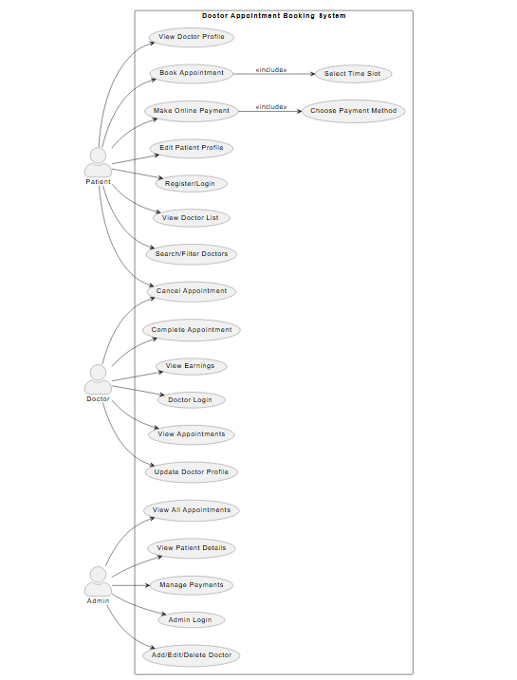

Fig: 3.1 USE CASE DIAGRAM

The above **Use Case Diagram** illustrates the core functionalities of the Doctor Appointment Booking System and how different users interact with it. The system supports three main actors—**Patient**, **Doctor**, and **Admin**—each with distinct responsibilities. Patients can register, search for doctors, book appointments, make payments, and manage their profiles. Doctors can manage appointments, view earnings, and update their information, while the Admin oversees doctor profiles, appointments, and system-wide operations. This diagram effectively captures the scope of interactions and helps visualize the user flow within the system.

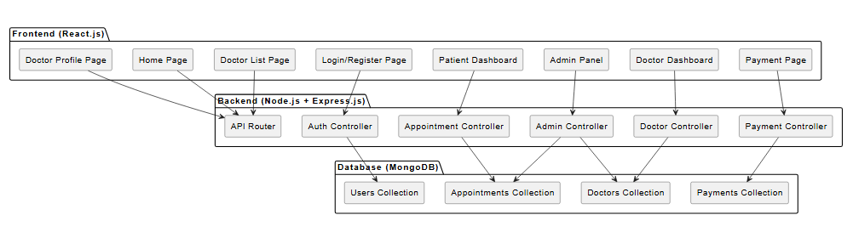

FIG 3.2 - STRUCTURE DIAGRAM

The above **System Structure Diagram** represents the architectural layout of the Doctor Appointment Booking System, built using the MERN stack. The system is divided into three main layers: **Frontend (React.js)**, **Backend (Node.js with Express.js)**, and **Database (MongoDB)**. Each component in the frontend corresponds to user-facing pages such as the home page, doctor listings, dashboards, and the payment interface. These components communicate with various backend controllers via API routes. The backend is responsible for handling business logic, managing user authentication, appointments, doctor and admin functionalities, and integrating payment services. All data is stored in MongoDB collections, ensuring structured and efficient access. This layered architecture enhances modularity, scalability, and maintainability of the system.

**CHAPTER 4**

### IMPLEMENTATION

#### 4.1 IMPLEMENTATION PHASE OVERVIEW

The implementation phase involves turning the system’s design and requirements into a working product. This phase will focus on the actual development of the **Doctor Appointment Booking System**, utilizing the chosen technologies — **MongoDB**, **Express.js**, **React.js**, and **Node.js**. The implementation is structured into several key stages, from initial setup and coding to testing and deployment.

The implementation of the **Doctor Appointment Booking System** began with setting up the development environment and configuring the necessary tools. Using the **MERN stack**, we laid the foundation by establishing the backend (Node.js with Express.js) and connecting it to the frontend (React.js). MongoDB was chosen as the database due to its scalability and flexibility, while payment gateways like **Razorpay** and **Stripe** were integrated for handling online payments.

The implementation followed an agile methodology, allowing iterative development with continuous feedback from stakeholders. This approach ensured that the system evolved to meet both functional and non-functional requirements effectively.

Key stages of the implementation include:

1. **Environment Setup**: Configuring the development environment with necessary tools and libraries.
2. **Database Setup**: Setting up MongoDB for storing user profiles, appointments, and payment details.
3. **Frontend Development**: Creating the user interface using React.js, ensuring it is intuitive and responsive across different devices.
4. **Backend Development**: Setting up the server using Node.js and Express.js, creating routes, and managing user authentication and data flow.
5. **Payment Gateway Integration**: Incorporating Razorpay and Stripe to handle online payments.
6. **Testing and Debugging**: Ensuring the system functions as expected through rigorous testing.

#### 4.2 AGILE DEVELOPMENT METHODOLOGY

The Agile Development Method was employed to ensure flexibility, iterative progress, and quick adaptation to changes. Agile practices, such as continuous integration, frequent code reviews, and sprint-based development, were followed to maintain high quality and address issues early in the development process.

During each sprint, specific features were developed and tested. Feedback loops from both users and the development team helped refine the system, ensuring it met user expectations and adhered to project requirements. The Agile approach allowed the development team to remain responsive to emerging challenges and adapt to user needs, ensuring an optimal final product.

**Process Followed in Agile Development**

1. **Concept and Planning**
   1. The project began with defining the core goals: a cashier-centric system focusing on menu management, inventory tracking, bill generation, and report visualization.
   2. A project backlog was created to list all required features, and tasks were prioritized based on user needs and system importance.
2. **Iteration Cycles -** The project was divided into multiple iterations (sprints), each lasting about 1-2 weeks. Each sprint involved:
   1. **Sprint Planning**: Selecting tasks from the backlog to be completed during the sprint.
   2. **Development**: Writing code for individual modules such as Inventory Management, Menu Management, and Reporting.
   3. **Testing**: Verifying that the developed features worked as expected and met user requirements.
3. **User Feedback Integration**

After every sprint, prototypes of the developed features were reviewed by stakeholders or potential users (cashiers). Feedback was gathered to refine the features further and make necessary adjustments. For example, changes were made to simplify the inventory update process based on cashier feedback.

1. **Incremental Delivery**

At the end of each sprint, a functional module or feature was delivered, ensuring consistent progress. This allowed the team to demonstrate completed features like the billing system or graphical reports early in the process.

1. **Final Integration and Testing**

Once all core features were completed, the system was tested as a whole. Integration testing ensured that modules such as Menu Management, Inventory Management, and Reporting worked seamlessly together. Rigorous user testing simulated real-world scenarios to identify and resolve any final issues.

1. **Deployment and Retrospective**

The application was deployed as a desktop system for cashier use. After deployment, a retrospective was conducted to review the development process, identify strengths, and discuss potential improvements for future projects.

**Benefits of Using Agile**

* **Flexibility**: Agile allowed the team to accommodate changes and refine features based on user feedback.
* **Transparency**: Regular updates and sprint reviews ensured stakeholders remained informed throughout the development process.
* **Risk Mitigation**: Early and continuous testing helped identify issues early, reducing the risk of major defects.

By following the Agile methodology, the team successfully delivered a high-quality, user-centric Cafe Management System that met the functional requirements and allowed for future scalability.

#### 4.3 DEVELOPMENT PROCESS

The development process was structured in clear phases, each focusing on different aspects of the project:

1. **Backend Development**:
   1. **Node.js** and **Express.js** were used to build the backend. The server handled routing, user authentication, and interaction with the MongoDB database.
   2. **RESTful API** endpoints were created for various functionalities such as user login, doctor appointment booking, profile management, and payment processing.
   3. **JWT Authentication** was implemented for user login to ensure secure access control for patients, doctors, and admins.
2. **Frontend Development**:
   1. **React.js** was used to create the frontend. It provided a component-based architecture that ensured modularity and reusability.
   2. The user interface (UI) was designed to be responsive and user-friendly, allowing users to easily navigate through the platform and book appointments.
   3. State management was handled using **React Context API** to manage user session states and appointment data.
3. **Database Development**:
   1. **MongoDB** was used for its NoSQL features, offering scalability and flexibility. It allowed the storage of complex documents such as user profiles, appointment records, and doctor profiles.
   2. Mongoose, an Object Data Modeling (ODM) library for MongoDB, was used to simplify database operations and ensure data consistency.
4. **Payment Gateway Integration**:
   1. **Razorpay** and **Stripe** were integrated to facilitate secure online payments for appointment bookings. The integration involved creating a secure flow where users can pay their appointment fees via credit/debit cards or other digital payment methods.
   2. The payment process was designed to update the doctor’s dashboard upon successful payment and reflect in the admin’s appointment list.
5. **Testing and Debugging**:
   1. The system underwent rigorous testing during the development process. This included functional testing (ensuring the app’s features worked as intended) and security testing (ensuring sensitive data was protected).
   2. The development team followed a test-driven approach, where unit tests and integration tests were written to catch potential issues early.

| **Technology** | **Purpose** | **Description** | | | | | |
| --- | --- | --- | --- | --- | --- | --- | --- |
| **JavaFX** | Frontend Development | | Used to design and implement the graphical user interface (GUI) for cashier interaction. | | |  |  |
| **Java** | Backend Development | | | Implements the core business logic, including inventory tracking, billing, and reporting. | |  |  |
| **MySQL** | Database Management | | | Stores and retrieves data such as menu items, inventory levels, user accounts, and reports. | |  |  |
| **NetBeans IDE** | Integrated Development Environment (IDE) | | | | Facilitates coding, debugging, and testing for Java and JavaFX applications. |  |  |
| **JDBC** | Database Connectivity | | | | Provides a connection between the application and the MySQL database. | |  |
| **Scene Builder** | GUI Design Assistance | | | | Helps visually design and layout JavaFX user interface components. | |  |
| **Windows OS** | Operating System | | | | Provides the desktop environment where the application runs for the cashier. |  |  |

Table 4.1 Technology stack

#### 4.4 CHALLENGES AND SOLUTIONS

During the implementation phase, several challenges were encountered and addressed:

1. **Authentication and Authorization**:
   1. **Challenge**: Ensuring secure login for patients, doctors, and admins, each having different levels of access.
   2. **Solution**: We implemented **JWT-based authentication** for user login, ensuring that the roles (patient, doctor, admin) were securely authenticated and authorized.
2. **Payment Gateway Integration**:
   1. **Challenge**: Integrating the payment gateway and ensuring that the payment process was smooth and secure.
   2. **Solution**: Detailed integration with **Razorpay** and **Stripe** was performed, including ensuring that payment confirmation was reflected in both the user and doctor dashboards.
3. **Data Management**:
   1. **Challenge**: Managing complex data models such as user profiles, doctor profiles, appointments, and payment statuses.
   2. **Solution**: MongoDB’s flexible schema allowed us to create efficient data models, and Mongoose provided an easy way to handle relationships between these models.
4. **User Interface Design**:
   1. **Challenge**: Creating an intuitive and responsive interface that catered to patients, doctors, and admins with different requirements.
   2. **Solution**: We used **React.js** to develop a dynamic user interface with responsive design principles, ensuring the system was accessible across devices.

**CHAPTER 5**

### DESIGN

System design is a crucial phase where the conceptual and physical structure of the system is outlined. For the Doctor Appointment Booking System, a clear and modular design was created to ensure scalability, maintainability, and user-friendliness. This chapter explains the overall architecture, interface layout, database structure, and system components.

#### 5.1 SYSTEM ARCHITECTURE DESIGN

The architecture of the system follows a modern web-based **three-tier architecture**, ensuring loose coupling between layers for better scalability and maintainability. It uses the MERN stack as the foundation and integrates an external **payment gateway** to process online transactions.

#### System Layers:

* **Frontend (React.js):**
  + Built as a single-page application (SPA) for seamless navigation
  + Uses React Router for client-side routing
  + Handles dynamic rendering based on user roles (patient, doctor, admin)
* **Backend (Node.js & Express.js):**
  + Exposes RESTful API endpoints
  + Performs authentication, authorization, validation, and data processing
  + Contains business logic for handling bookings, payments, and profile updates
* **Database (MongoDB):**
  + Stores unstructured and semi-structured data using collections
  + Provides flexibility to evolve data models over time
  + Connects via Mongoose ORM for better query handling
* **Payment Gateway Integration:**
  + Uses **Razorpay** or **Stripe**
  + Securely collects and verifies payment details
  + Communicates with backend to update payment status and issue receipts

#### Role-Based Access Design:

Each user role accesses the system differently:

* **Patients** interact with doctor listings, appointment booking, and payments.
* **Doctors** manage their availability, earnings, and patient appointments.
* **Admins** oversee the entire system, add/manage doctors, and view analytics.

#### 5.2 USER INTERFACE DESIGN

The User Interface (UI) is a core part of the Doctor Appointment Booking System, designed using **React.js** for a fast, responsive, and dynamic user experience. The design follows a **role-based approach**, ensuring each type of user—**patient, doctor, and admin**—has access to the tools and data relevant to their needs. The UI is built to be **clean, easy to navigate**, and **responsive across devices**.

#### Role-Based Interface Design

* **Patient Interface:**
  + Homepage includes banners, specialty highlights, and featured doctors.
  + Patients can browse all doctors and filter by specialty (e.g., Dentist, Cardiologist).
  + Doctor profile pages show qualifications, consultation fee, and available time slots.
  + Appointment booking allows patients to pick a date/time and confirm the booking.
  + Logged-in users can view their appointment history, cancel bookings, and make online payments.
  + Patients can also edit their profile information and upload/update a profile picture.
* **Doctor Interface:**
  + The dashboard displays total patients, completed appointments, and earnings.
  + Doctors can view all bookings with patient details, date, time, and payment status.
  + Appointments can be marked as completed or canceled directly from the dashboard.
  + Profile editing includes updating description, consultation fee, specialty, and address.
* **Admin Interface:**
  + Admin dashboard shows system-wide stats: total doctors, patients, and appointments.
  + Admins can manage doctor profiles—add, edit, or delete records.
  + A dedicated view for monitoring all appointments, with filters by doctor, date, or status.
  + Admins can also track payments and oversee user activity.

#### Design Features

* **Responsiveness:**
  + UI adjusts seamlessly across desktops, tablets, and smartphones.
  + Grid layouts, media queries, and flexible components support all screen sizes.
* **Navigation:**
  + Uses **React Router** for smooth client-side routing and dynamic URL mapping.
  + Sidebars or top navigation bars for easy access to dashboard features.
  + Conditional rendering ensures users only see what’s relevant to their role.
* **Reusable Components:**
  + Shared components like headers, footers, modals, and forms are reused across pages.
  + Modular design helps in easier maintenance and faster development.

#### User Experience Enhancements

* **Visual Feedback:**
  + Toast notifications for booking success, payment confirmation, and errors.
  + Loaders and animations improve interactivity and user trust.
* **Form Validations:**
  + All forms include real-time field validation (e.g., required fields, email format).
  + Clear error messages guide the user to correct mistakes easily.
* **Accessibility:**
  + Fonts, colors, and spacing are optimized for readability.
  + Alt text, keyboard navigation, and high contrast options support accessibility standards.

#### Styling and Tools

* **React.js** for dynamic rendering and state management.
* **CSS Frameworks** like Bootstrap or Tailwind for quick and responsive design.
* **Font Awesome / Material Icons** for visual indicators and user-friendly navigation.
* **Axios** used to communicate with backend APIs securely.
* Optional libraries like **Formik/Yup** used for advanced form handling and validation.

#### 5.3 DATABASE DESIGN

#### The Doctor Appointment Booking System uses MongoDB, a flexible NoSQL database, to store and manage all system data. The database is organized into multiple collections that support different functionalities of the platform. Relationships between documents are handled using ObjectId references.

#### Key Collections

* **Users**  
   Stores all system users including patients, doctors, and admins.  
   **Fields:** name, email, password, role, createdAt
* **Doctors**  
   Stores doctor-specific information linked to a user.  
   **Fields:** userId, specialty, degree, experience, fee, description
* **Appointments**  
   Stores all appointment bookings. Linked to both doctor and patient.  
   **Fields:** doctorId, patientId, date, time, status, paymentStatus
* **Payments**  
   Stores payment records for appointments made via Razorpay or Stripe.  
   **Fields:** appointmentId, transactionId, amount, status, paidAt

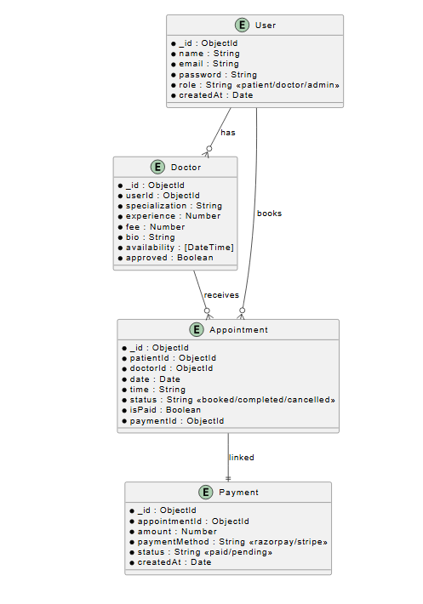

FIG 5.1 DATABASE DIAGRAM

#### 5.4 COMPONENT DESIGN

#### The frontend uses React’s component-based architecture to split the UI into logical, reusable pieces. Each module (auth, profile, appointments) has its own component directory for structure and clarity.

#### Core Component Structure:

#### Authentication Components: Login, Signup, Protected Routes

#### Patient Components: BookAppointment, DoctorList, MyAppointments

#### Doctor Components: Dashboard, ProfileEditor, AppointmentManager

#### Admin Components: AddDoctorForm, DoctorListAdmin, AppointmentOverview

#### Shared Components: Header, Footer, Modal, Notification, Loader

#### State Management:

#### Local state handled via useState, and global auth/user state managed via React Context API

#### Axios is used for API calls, while interceptors handle token-based requests

#### Routing:

#### React Router DOM is used to map role-based navigation and dynamic URL rendering

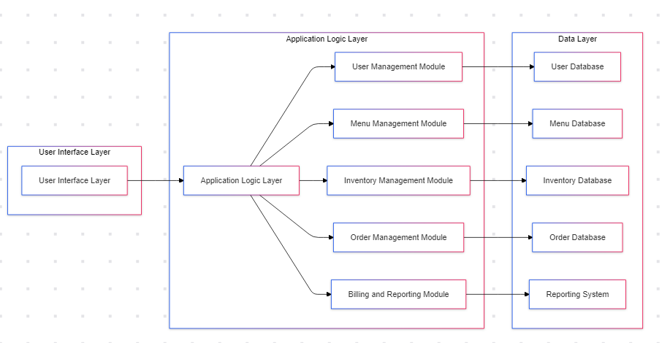

FIG 5.2 COMPONENT DIAGRAM

#### 5.5 DESIGN GOALS

The design of the Doctor Appointment Booking System was guided by several key goals aimed at delivering a modern, secure, and user-friendly platform for all user roles. These goals shaped both the frontend and backend structure of the application.

#### 1. Role-Based Accessibility

* Ensure each user (patient, doctor, admin) only has access to features and data relevant to their role.
* Implement route protection and conditional rendering in the frontend.

#### 2. Simplicity and Usability

* Maintain a clean, intuitive interface for users of all technical backgrounds.
* Use clear navigation, readable fonts, and form validations to enhance user experience.

#### 3. Scalability

* Use MongoDB and modular components to allow future growth in users, doctors, and appointment data.
* Design APIs and database schema in a way that supports easy expansion and integration.

#### 4. Data Security

* Secure sensitive data like passwords using encryption (bcrypt).
* Ensure safe payment transactions using trusted gateways like Razorpay or Stripe.

#### 5. Performance Optimization

* Optimize database queries, minimize API load time, and use caching where applicable.
* Use lightweight components in React to keep the UI fast and responsive.

#### 6. Mobile Responsiveness

* Design layouts to be fully responsive using CSS frameworks like Bootstrap or Tailwind.
* Ensure usability on all screen sizes including smartphones and tablets.

#### 7. Reusability and Maintainability

* Build reusable components and modular backend routes to make the codebase easier to maintain and scale.
* Follow clean code principles and maintain clear folder structures.

### CHAPTER 6

### PROJECT FLOW

#### 6.1 FLOW

The application is designed to support three main types of users—**patients**, **doctors**, and **admins**—each with a distinct workflow and a customized interface. The logic behind the project flow ensures that each user interacts only with features relevant to their role, maintaining both usability and security.

#### A. Entry Point and Authentication

The flow begins when a user accesses the web application via the homepage. From here, they have options to explore doctors, learn about the platform, or proceed to login or registration.

* **Authentication Process:**
  + The user is prompted to register or log in.
  + Upon successful login, a **JWT (JSON Web Token)** is issued and stored securely.
  + Based on the user’s role (stored in the database), the user is redirected to their respective dashboard (Patient Dashboard, Doctor Dashboard, or Admin Panel).

This role-based redirection ensures that every user views only the features they are authorized to access, implementing the principle of **separation of concerns**.

#### . Patient Workflow

Once authenticated, a **patient** can perform the following tasks:

* Browse the list of available doctors.
* Filter doctors based on their medical specialty.
* View a detailed profile of a doctor, including qualifications, experience, availability, and fees.
* Choose a convenient date and time slot for an appointment.
* Confirm the booking and proceed to make an online payment (optional at booking stage).
* View their appointment history and manage their bookings (cancel, reschedule, or pay).
* Update their profile details such as name, image, or contact information.

The patient workflow is built for simplicity and speed. Clear call-to-action buttons, visual appointment calendars, and real-time validations enhance the user experience. Each appointment is stored in the backend with references to both the doctor and the patient, maintaining relational consistency using MongoDB references.

#### C. Doctor Workflow

When a **doctor** logs in, they are redirected to their personalized dashboard. The workflow includes:

* Viewing a summary of appointments, earnings, and total patients served.
* Checking upcoming and past appointments with patient details.
* Marking appointments as **completed** or **canceled**.
* Updating professional details such as consultation fee, address, and profile description.

This flow ensures that doctors have access to everything they need to manage their professional services efficiently. It promotes **self-service** and autonomy, reducing the administrative burden.

#### D. Admin Workflow

Admins have the highest level of access and control within the system. Their workflow includes:

* Viewing system-wide analytics: total users, appointments, and payments.
* Managing doctor profiles: adding new doctors, updating credentials, or removing inactive profiles.
* Monitoring appointment activity across all users.
* Verifying payment status and resolving booking issues if required.

The admin workflow is essential for **platform governance** and **quality assurance**. A simplified interface with detailed forms and filters enables the admin to carry out system management tasks effectively.

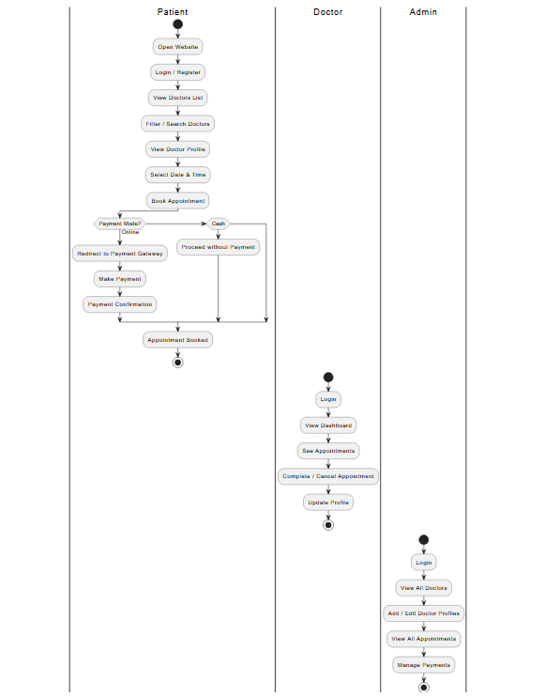

FIG 6.1 FLOWCHART

* **Real-time Data Updates**: Whenever changes are made in the menu, inventory, or orders, the system ensures that the data is updated in real time across all modules.
* **Integration Between Modules**: The Order Management and Inventory Management systems are closely linked. When an order is placed, inventory is updated immediately to reflect the change in stock levels.
* **Efficient Reporting**: The Reporting Module provides valuable insights into the business’s performance, such as sales trends and inventory consumption, helping the cashier make informed decisions about menu offerings and stock management.

### 6.2 Backend and Database Interaction

Every action initiated on the frontend triggers a corresponding **API call** to the backend. These APIs, built using **Express.js**, handle:

* Input validation
* Authentication and authorization
* Database operations via **Mongoose** (MongoDB ODM)
* Payment verification with Razorpay/Stripe

Once processed, responses are sent back to the frontend for UI updates. This **client-server model** ensures separation between presentation and logic layers, which improves security and scalability

### 6.3 Appointment and Payment Workflow

* When a patient books an appointment:
  + The system checks the selected slot for availability.
  + If the slot is available, an appointment is created in the database with status “Booked”.
  + Payment can be made immediately or later via a secure link.
* For online payments:
  + A payment session is created with the Razorpay/Stripe API.
  + Upon successful transaction, the system updates the appointment status to “Paid” and records the transaction ID.

### 6.4 Session and Logout Flow

Session management is handled using **JWT tokens**, ensuring secure access to protected routes. When a user logs out:

* The token is cleared from local storage or cookies.
* The session is terminated.
* The user is redirected to the homepage, ensuring all private data is cleared from the session.

#### 6.5 DIAGRAM REPRESENTATION

The **Diagram Representation** section visually illustrates the flow and structure of the **Doctor Appointment Booking System** through various diagrams, including the **Use Case Diagram**, **Data Flow Diagrams (DFD)**, **Entity-Relationship Diagram (ERD)**, and **Project Flow Diagrams**. These diagrams represent the key interactions and data flows within the system, highlighting how patients, doctors, and admins interact with the system. The **Use Case Diagram** shows the different roles and their functionalities, such as booking appointments and managing profiles. The **DFD** outlines the flow of information across the system, detailing the processes like user registration, appointment scheduling, and payment processing. The **Entity-Relationship Diagram (ERD)** visualizes the relationships between data entities such as users, doctors, and appointments. Finally, the **Project Flow Diagram** outlines the sequence of activities from login and menu management to payment and report generation, ensuring that all components of the system work together smoothly for efficient operations. These visual representations help in understanding the system's architecture and user interactions, providing a clear and structured view of the project’s workings.

DATA FLOW DIAGRAM

LEVEL 0

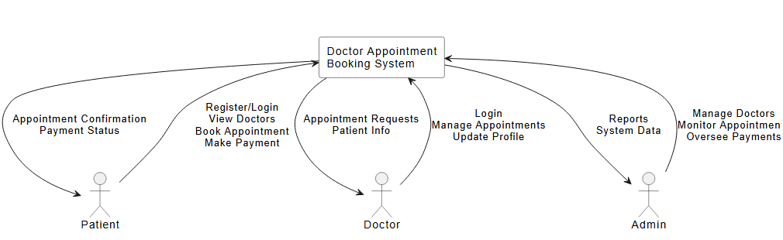

Fig 6.2 DFD 0

The **Level 0 DFD** represents the system's overall structure in its simplest form. It includes the main external entities (patients, doctors, and admins) and the core system. The diagram shows the high-level interactions between users and the system, such as registering/logging in, booking appointments, and managing payments. This diagram provides a foundational view of how the system interfaces with external users and initiates key processes.

LEVEL 1

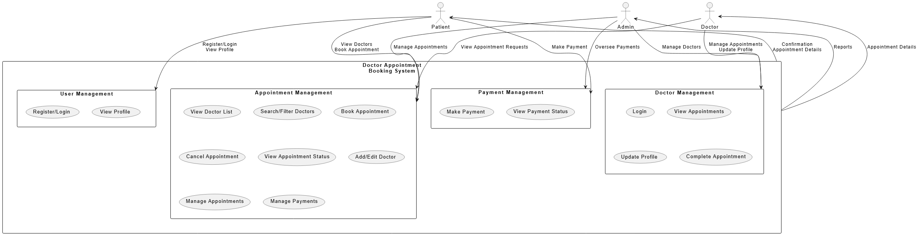

Fig 6.3 DFD 1

The **Level 1 DFD** provides a high-level overview of the **Doctor Appointment Booking System**, showing the major subsystems and how they interact with users (patients, doctors, and admins). It illustrates the flow of data between actors and subsystems, such as user registration, booking appointments, making payments, and managing doctor profiles.

LEVEL 2

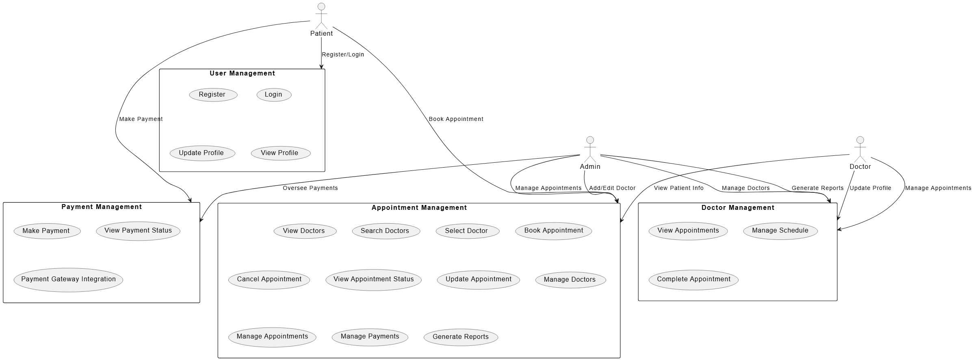

Fig 6.4 DFD 2

The Level 2 DFD details the internal processes of the **Doctor Appointment Booking System**. It breaks down key functionalities into specific tasks, such as user registration, appointment booking, payment processing, and doctor management. Each subsystem, like **User Management**, **Appointment Management**, and **Payment Management**, defines clear processes that handle interactions between patients, doctors, and admins. This diagram provides a comprehensive view of how data flows and is processed at each stage, ensuring smooth operations throughout the system.

### CHAPTER 7

### PROJECT SCREENSHOT

#### 7.1 HOME PAGE

The homepage is the first point of interaction for users visiting the website. The layout provides users with options to browse doctors, view specialties, and navigate through other parts of the system.

* **Features**:
  + Banner with navigation options (Browse Doctors, Specialties, etc.)
  + A list of top doctors, making it easy for users to find doctors with excellent ratings.
  + Links to **Login** or **Sign Up** for patients to create an account or access their existing account.

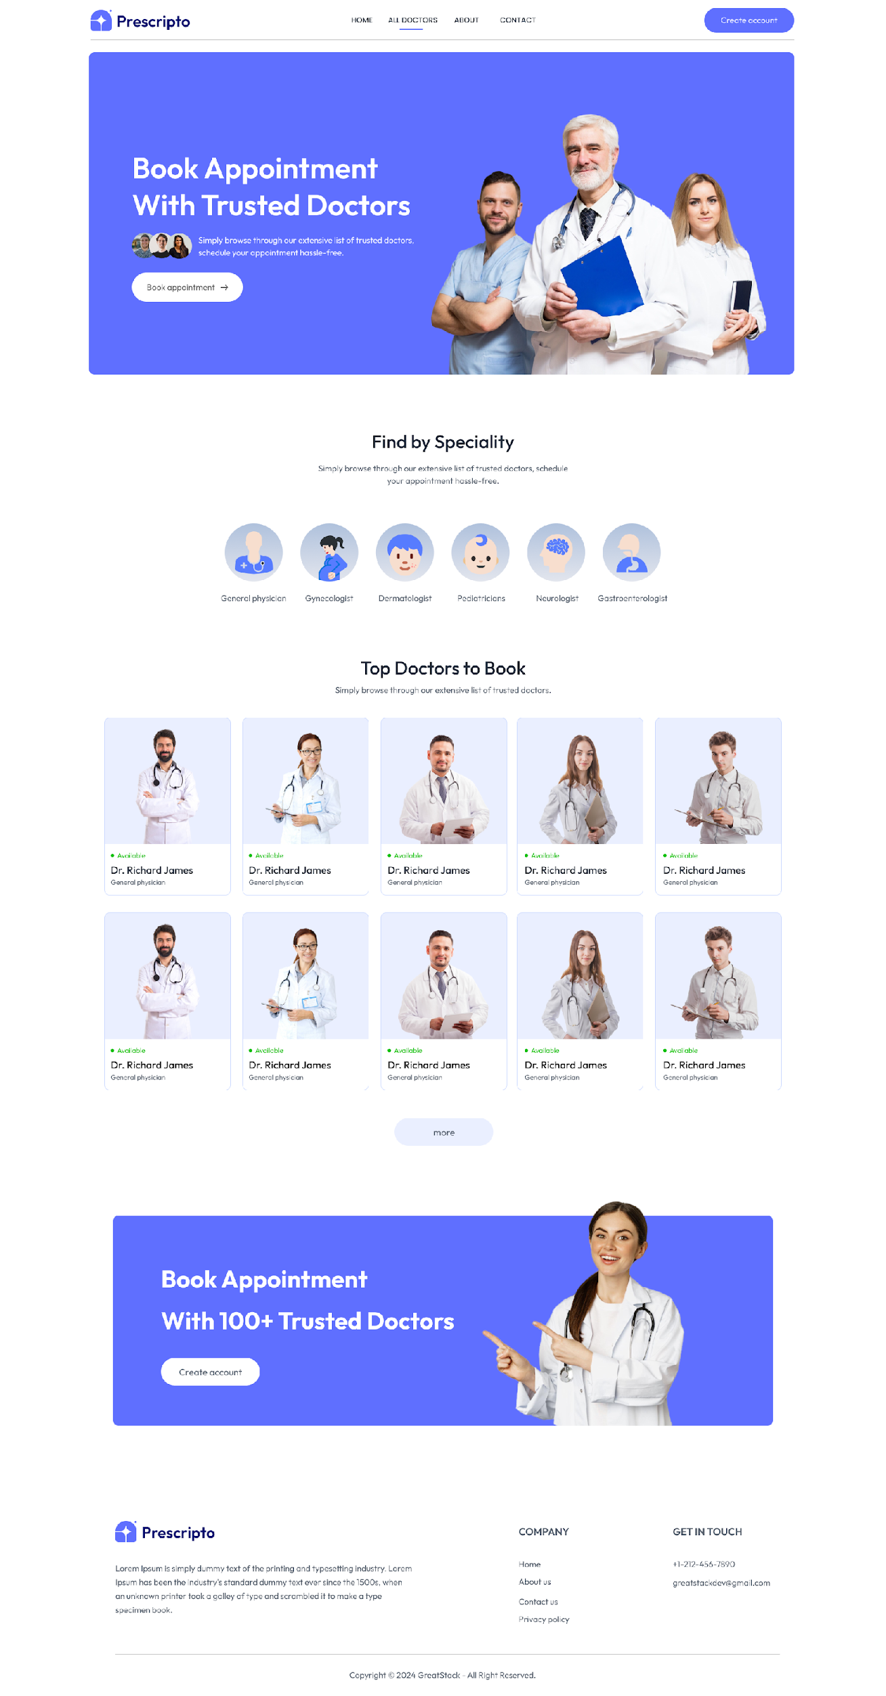

FIG 7.1 HOME PAGE

#### 7.2 APPOINTEMNET PAGE

The Once logged in, patients can select a doctor from the list and navigate to the doctor's profile page. This screen provides detailed information about the doctor, including their specializations, consultation fees, and available time slots.

* **Features**:
  + Doctor details (Name, Degree, Specialization, Experience, etc.).
  + Available time slots for appointment booking.
  + **Book Appointment** button for booking a time slot with the selected doctor.

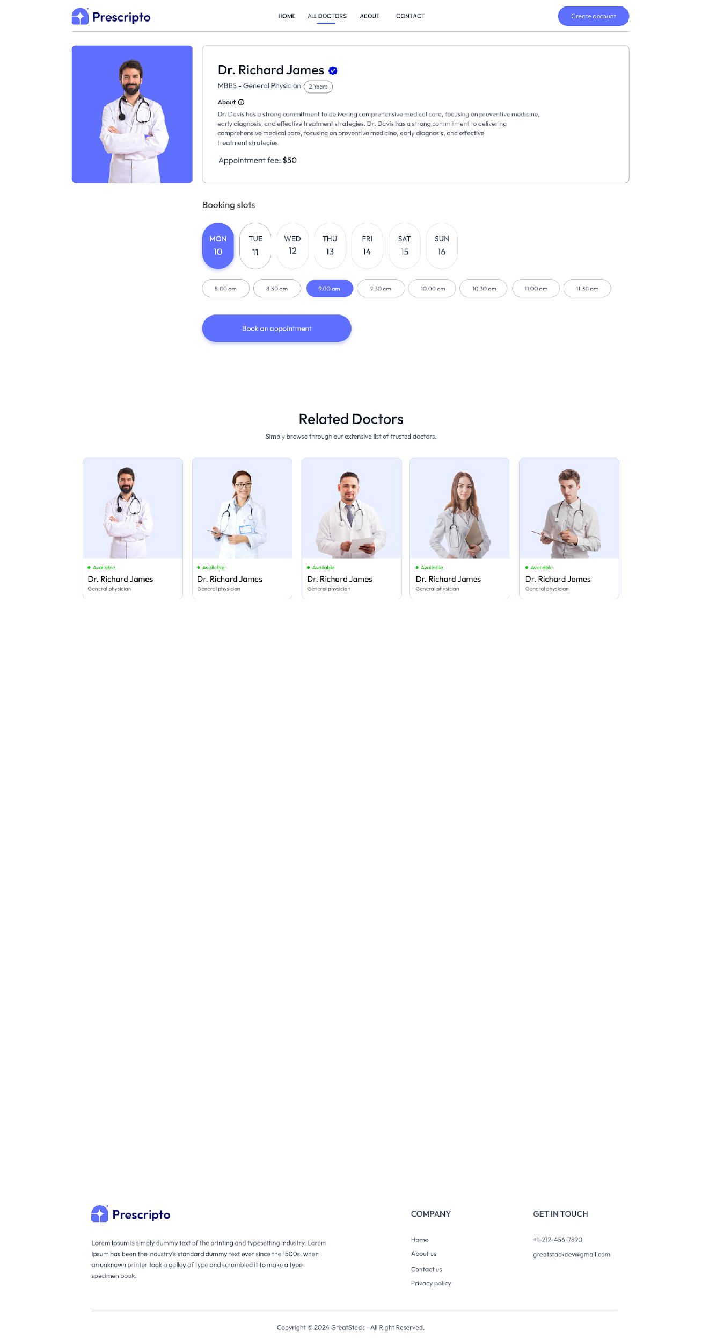

FIG 7.2 APPOINTMENT PAGE

#### 7.3 DOCTOR LIST

The **Doctor List** feature allows patients to browse and filter through a list of doctors based on specialties, experience, and availability. Each doctor’s profile includes their name, qualifications, consultation fee, and available time slots. The list is equipped with search functionality and filters for specialties and other criteria, helping users find suitable doctors quickly.

Patients can click on a doctor’s profile to view more detailed information, including a description, experience, and consultation fee. The system also offers sorting options by name, experience, or fee. Additionally, the page displays **Related Doctors** in the same specialty, allowing users to compare options.

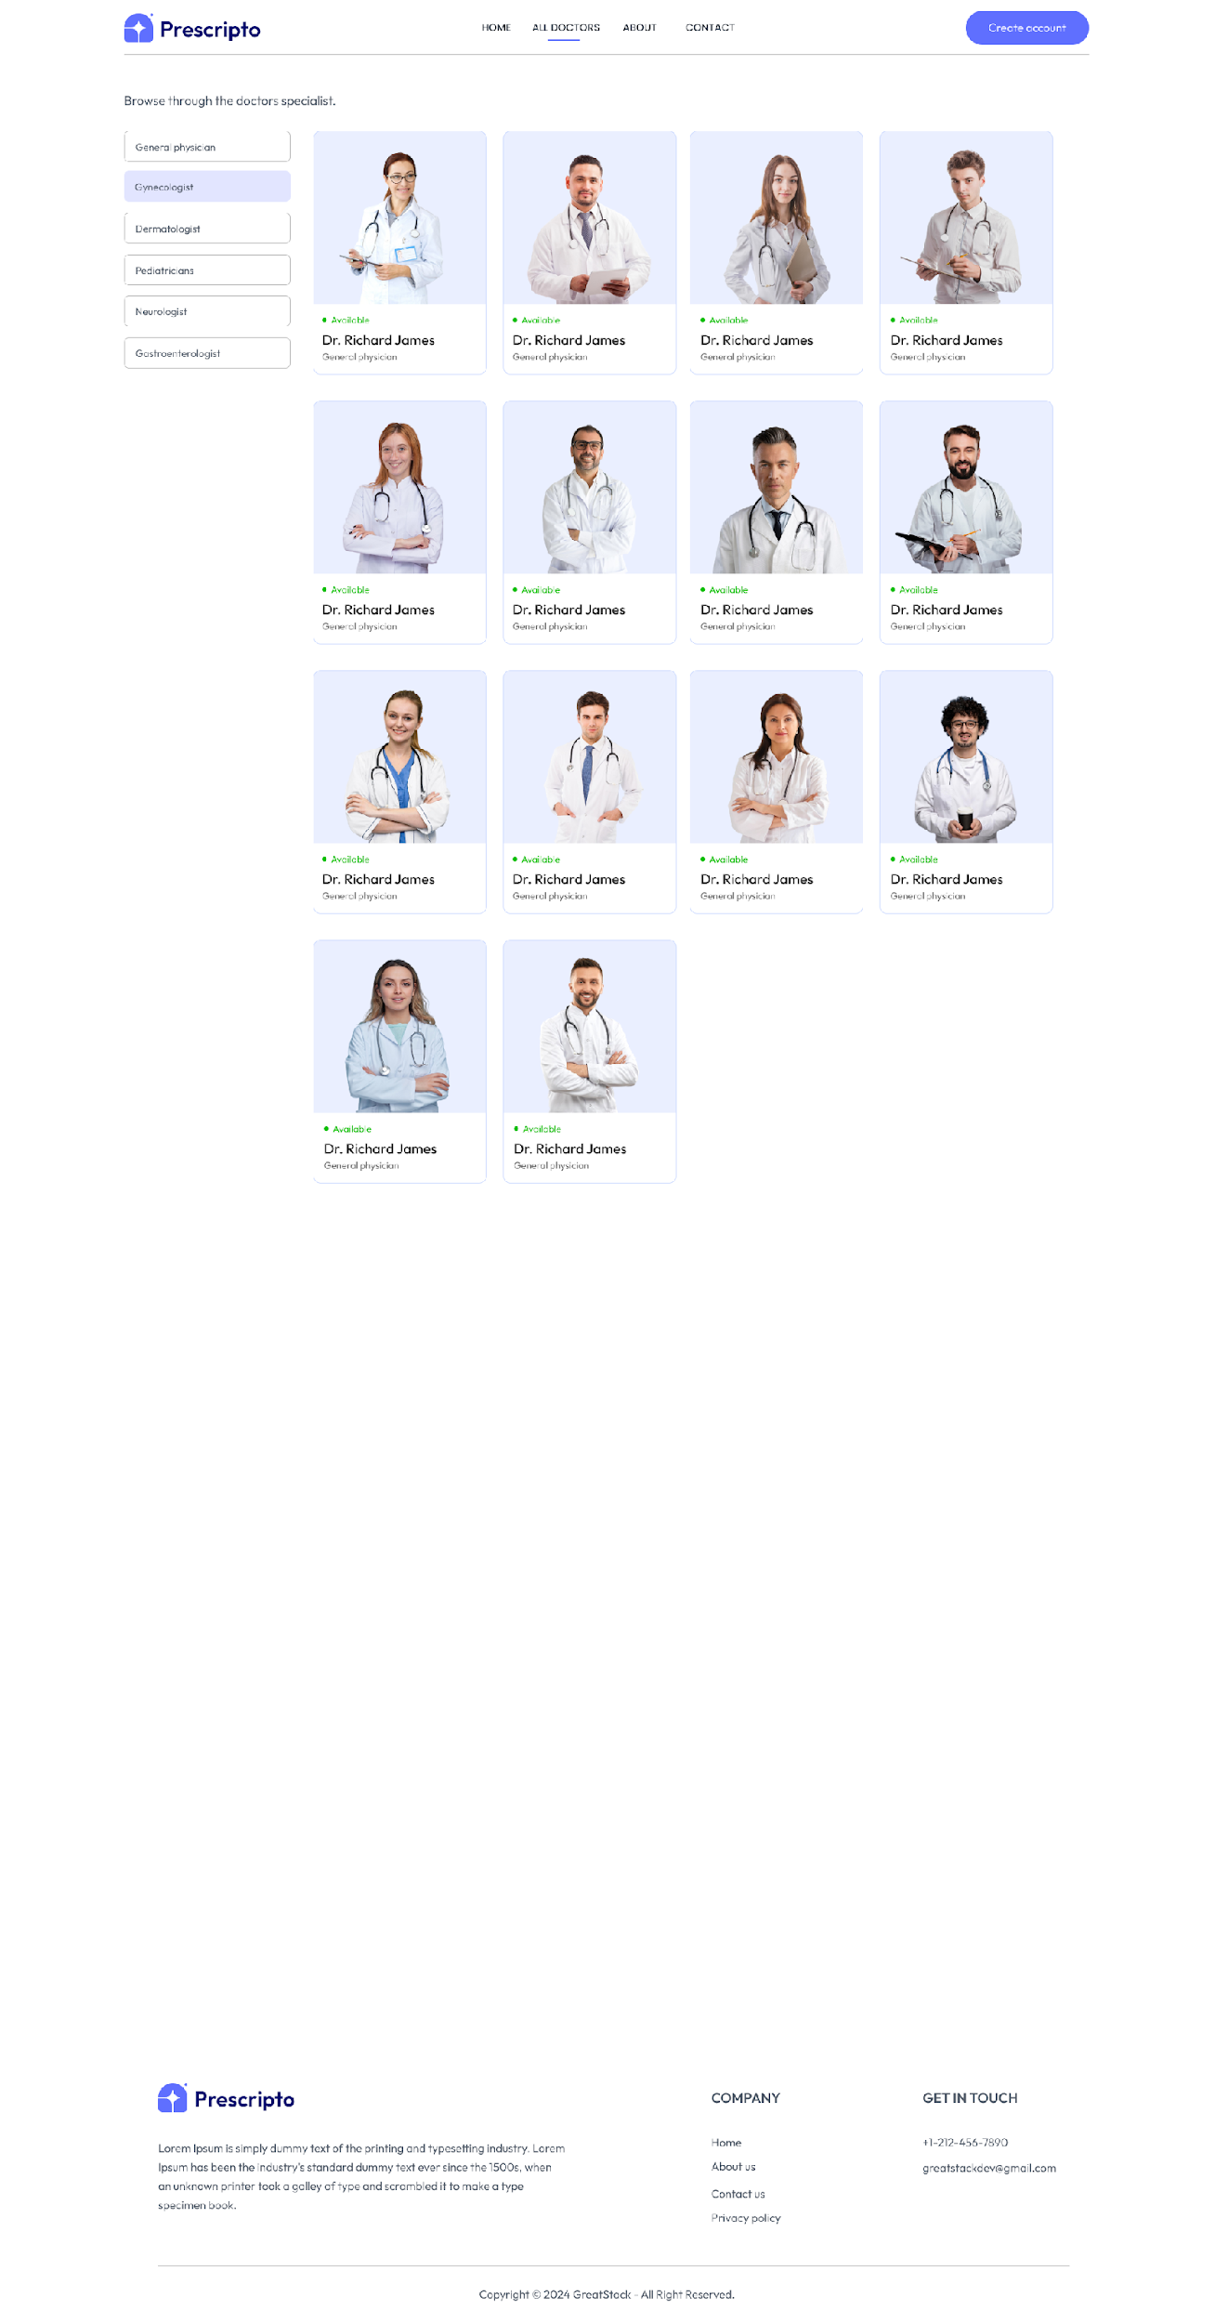

FIG 7.3 ALL DOCTOR PAGE

#### 7.4 ABOUT/CONTACT PAGE

The **Menu Management Page** is designed to help the cashier efficiently manage the cafe's menu offerings. It provides a centralized interface for adding, updating, and organizing menu items.

Key Features:

* **View Menu Items**: Displays all available menu items in a categorized format for easy browsing.
* **Add New Items**: Allows the cashier to quickly add new items to the menu, including details like name, price, and category.
* **Edit Existing Items**: Facilitates updating the details of menu items, such as price changes or category adjustments.
* **Delete Items**: Enables the removal of outdated or unavailable items from the menu.

This page simplifies the process of maintaining an up-to-date menu, ensuring that the cashier can make real-time adjustments to reflect the cafe’s offerings accurately. The intuitive design enhances the overall efficiency of menu management.

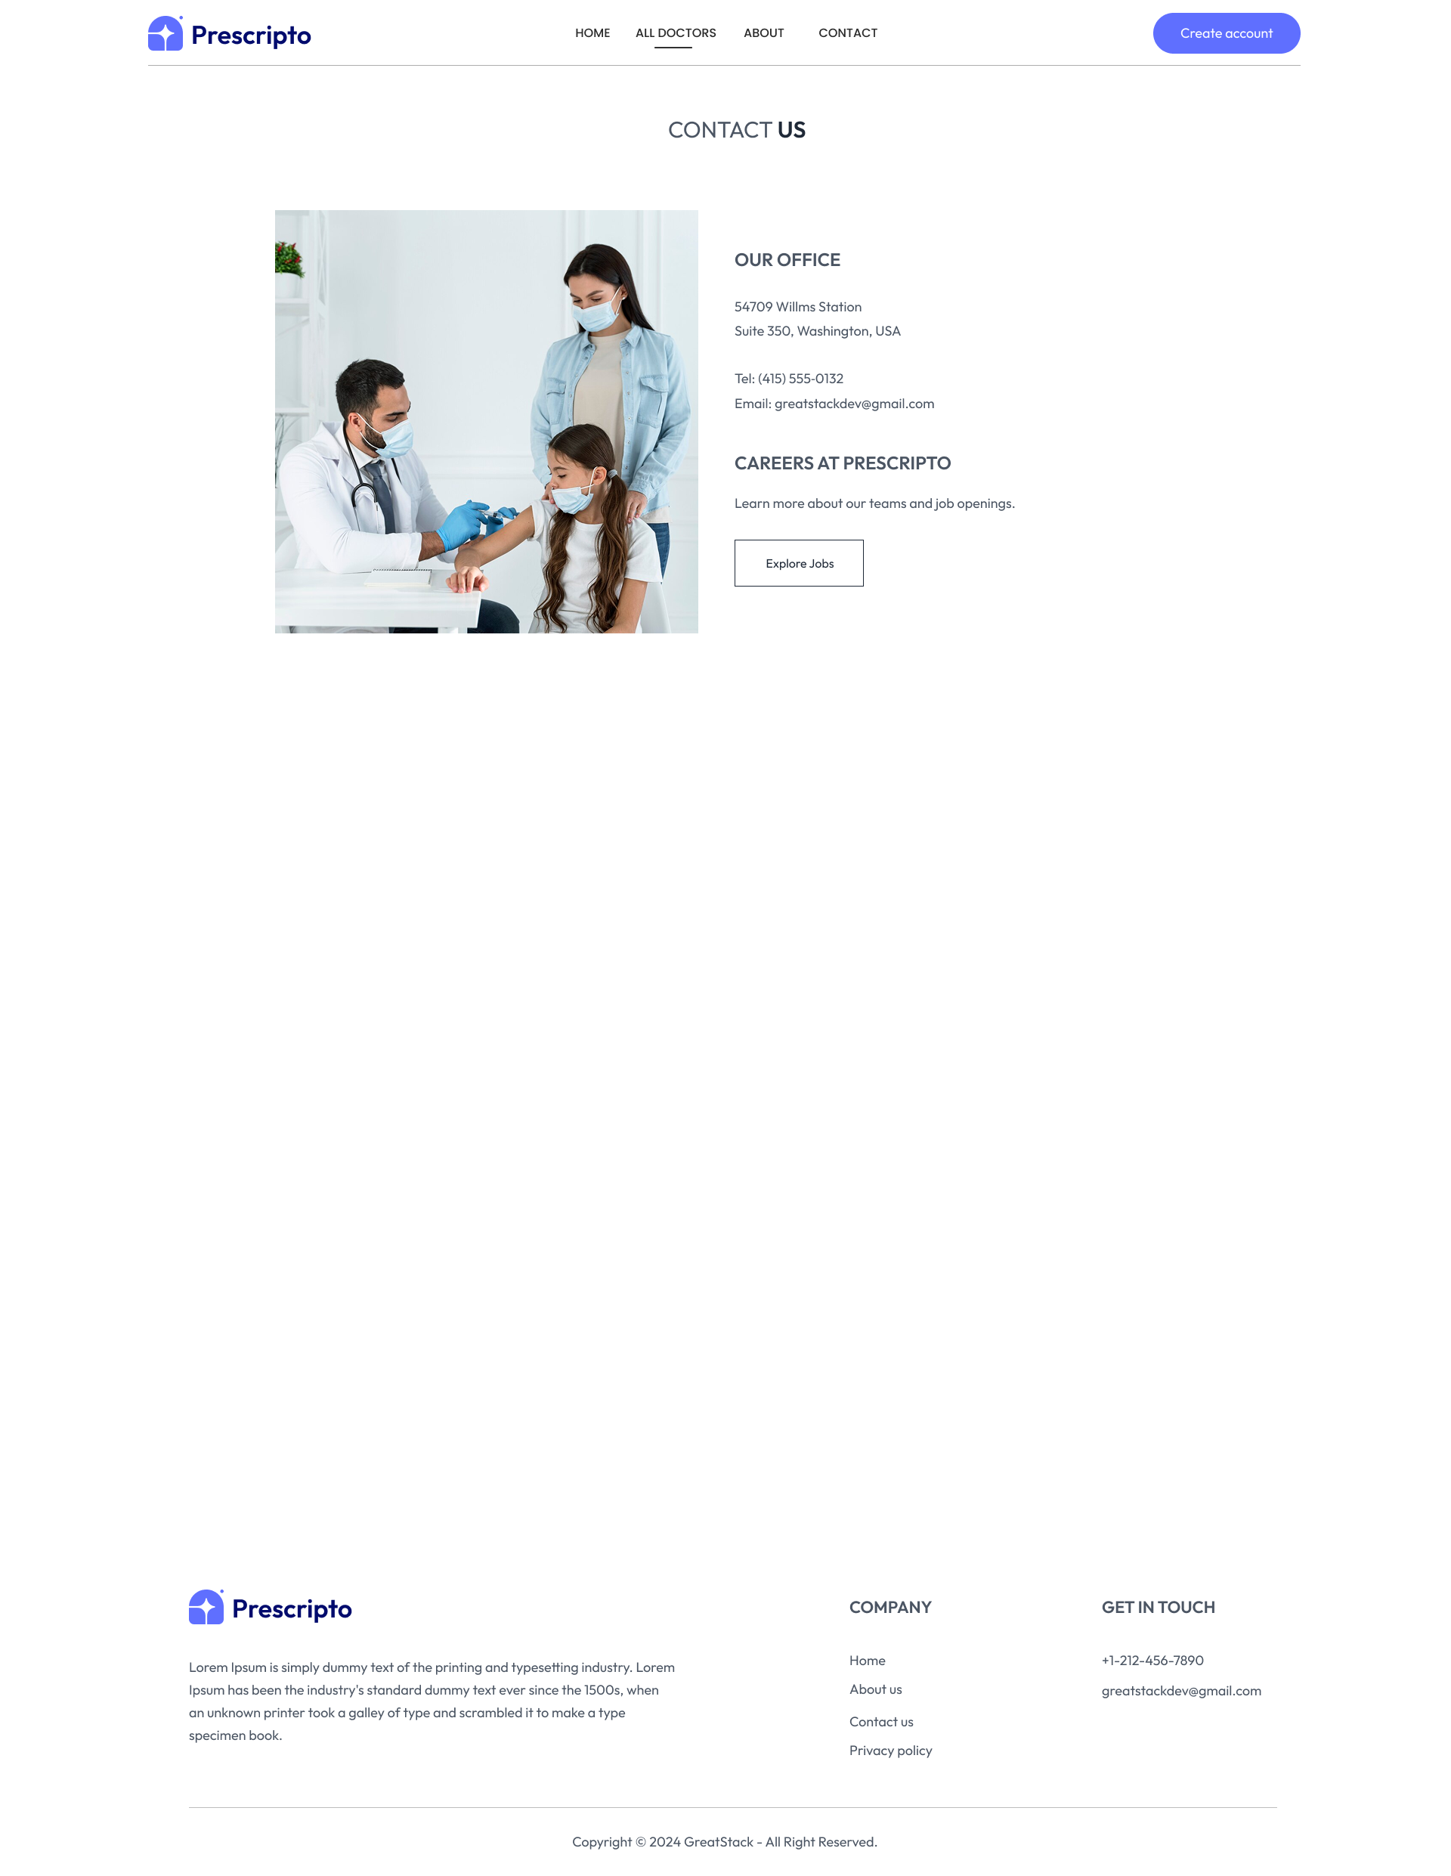

FIG 7.4 CONTACT PAGE

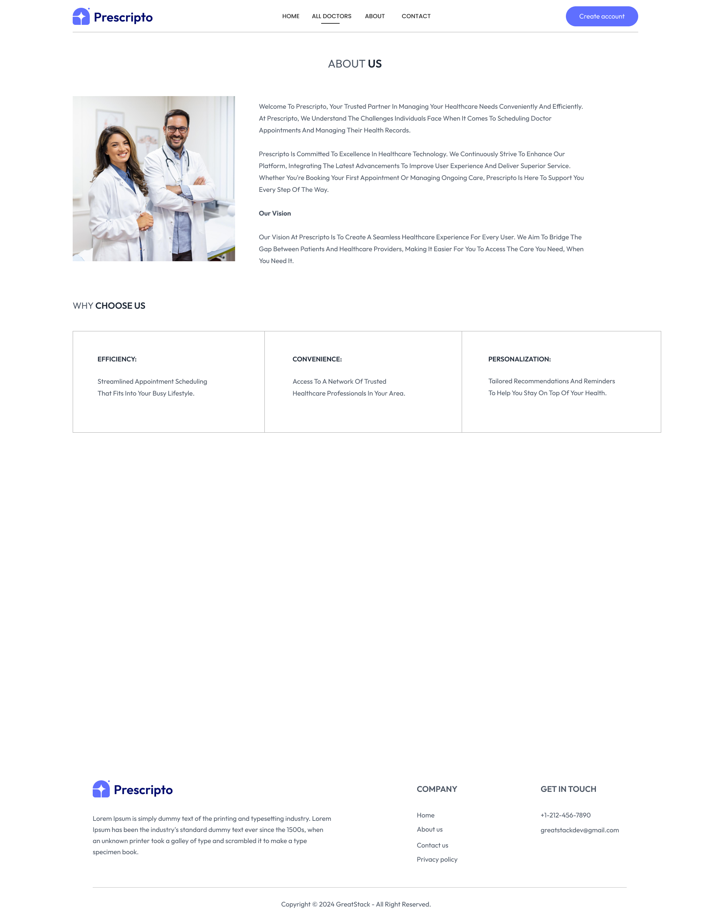

FIG 7.4 ABOUT PAGE

#### 7.5 ADMIN PANEL

The Admin dashboard allows administrators to manage the entire system. Admins can **view all appointments**, **manage doctor profiles**, **track payments**, and generate reports. It serves as the control center for the website.

* **Features**:
  + A list of **all doctors** and options to add or edit their profiles.
  + **Appointment list** that allows the admin to see all scheduled, completed, and canceled appointments.

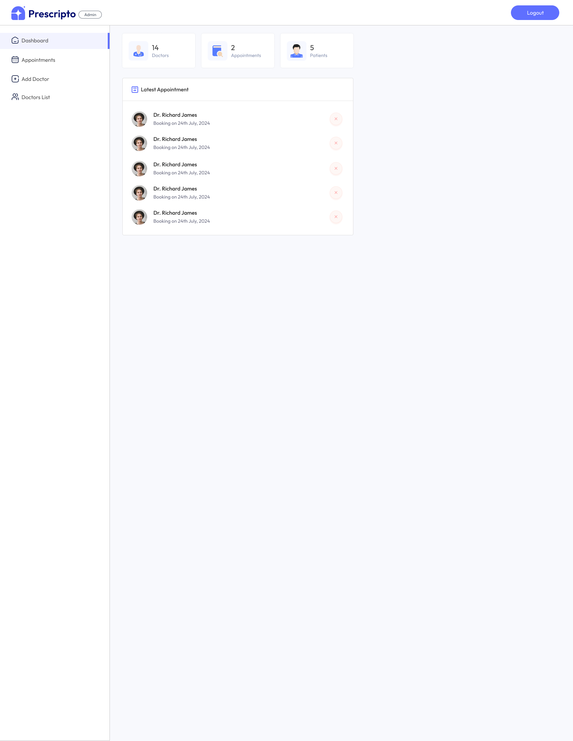

FIG 7.5 ADMIN PAGE

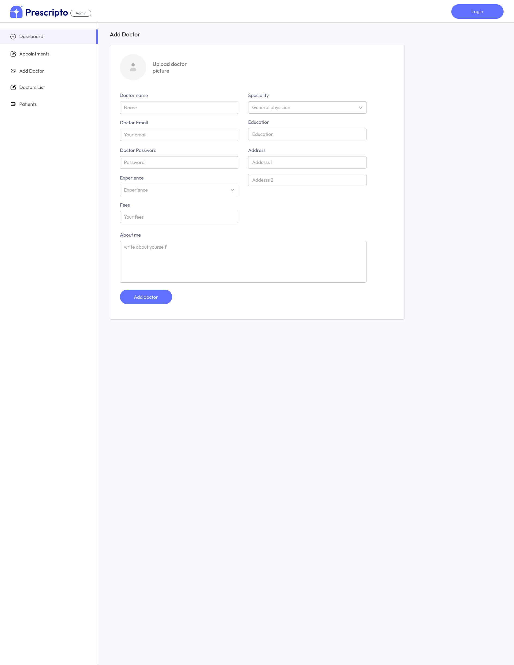

FIG 7.6 ADMIN PAGE

#### 7.6 DOCTOR PANEL

Doctors can log in to their dashboard, where they can manage their schedules, view patient appointments, and update their personal details.

* **Features**:
  + **View Appointments**: List of all upcoming and past appointments.
  + **Accept/Reject Appointments**: Doctors can either confirm or decline appointments.
  + **Earnings Report**: Doctors can see their total earnings from consultations.

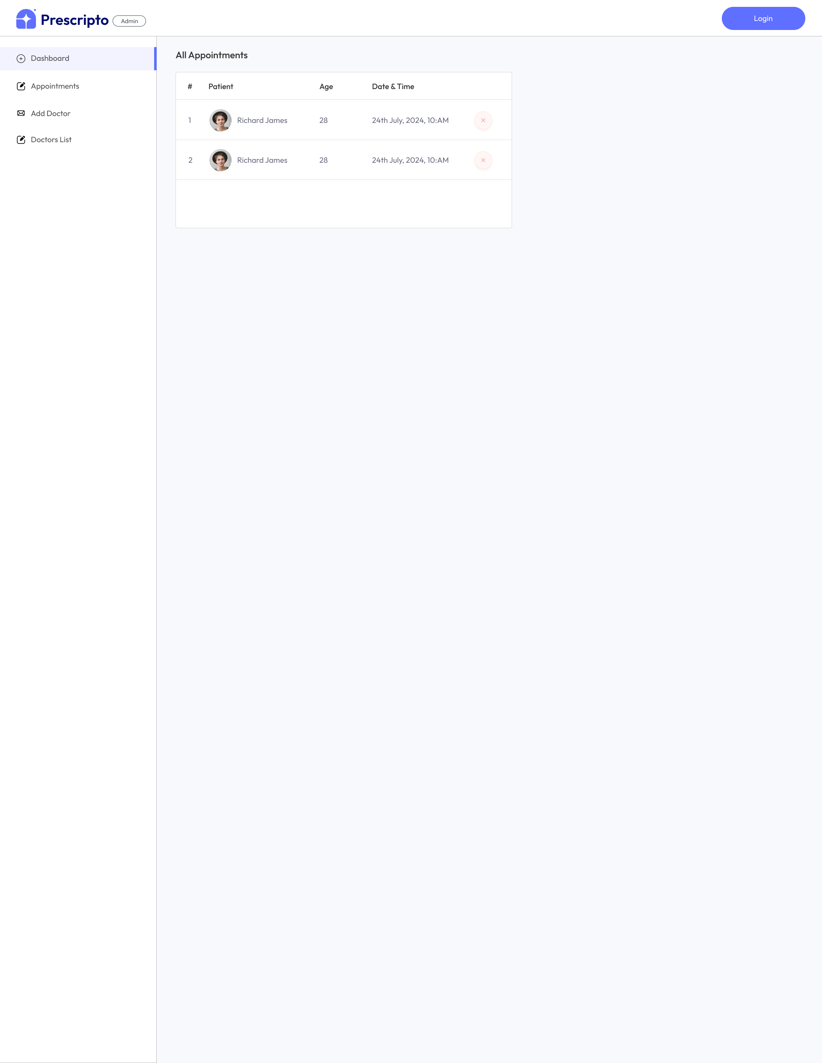

FIG 7.7 SIGN UP PAGE

### CHAPTER 8

### FUTURE SCOPE

* AI Integration for Smart Scheduling  
   The future implementation of Artificial Intelligence (AI) could significantly enhance the user experience of the Doctor Appointment Booking System. By integrating AI, the system could predict the most optimal appointment slots based on patient preferences, doctor availability, and historical data. AI could also offer personalized doctor recommendations based on the patient's medical history and specific needs, improving the chances of successful treatments.
* Telemedicine Capabilities  
   With the rise in remote healthcare services, integrating telemedicine features would be a significant upgrade. This could allow patients to have virtual consultations with doctors via video calls, which would be a more convenient option for non-emergency consultations. The system could include a feature for a virtual waiting room where patients can wait for their consultation, mimicking the in-office experience online. This would be especially beneficial for patients in rural areas or those unable to visit a doctor's office due to time or mobility issues.
* Multi-Language and Multi-Currency Support  
   To cater to a global audience, adding support for multiple languages and currencies would make the platform more accessible to a broader demographic. With multi-language functionality, patients from various linguistic backgrounds could navigate the website and interact with the system in their native language. Additionally, multi-currency support would be essential for international patients, allowing them to make payments in their local currencies, which would increase the platform's usability and marketability.
* Integration with Health Insurance Systems  
   Integrating health insurance capabilities into the system would allow patients to automatically check insurance eligibility when booking appointments. The platform could also support direct insurance claim submissions, making the payment process smoother for patients with coverage. Insurance verification could be done in real time, enabling seamless billing and reducing the need for manual processing. This integration would increase the system's efficiency and convenience, especially for patients who rely on insurance to cover medical costs.
* Advanced Analytics and Reporting Tools  
   The system could benefit from more advanced analytics and reporting features. By integrating tools for real-time tracking and analysis of patient appointments, doctor performance, and financial data, administrators could make informed decisions about resource allocation and system improvements. Doctors could receive detailed insights into their earnings, patient ratings, and appointment trends, while patients could track their medical history and appointment data. Predictive analytics could also be added to forecast high-demand periods and help in appointment scheduling.
* Security Enhancements and Compliance  
   As healthcare systems deal with sensitive patient data, ensuring robust security measures is crucial. Future updates could focus on implementing end-to-end encryption for all patient information, ensuring that both personal and medical data are secure. Additional features such as Two-Factor Authentication (2FA) could be integrated to provide an extra layer of protection for user accounts. Furthermore, the platform could be updated to comply with international data privacy regulations like HIPAA (Health Insurance Portability and Accountability Act) and GDPR (General Data Protection Regulation), ensuring the system meets global standards for data protection.
* Mobile Application Development  
   The creation of mobile applications for iOS and Android would increase accessibility, enabling patients, doctors, and administrators to manage appointments on the go. Mobile applications would allow users to book, view, and manage appointments from their smartphones, and receive notifications and reminders about upcoming consultations. With the increasing reliance on smartphones, a mobile version of the system would improve user engagement and expand the system's reach to a wider audience.
* Integration with IoT and Wearables  
   The integration of Internet of Things (IoT) devices and wearable health monitors could allow doctors to monitor patients remotely. Real-time data from devices like heart rate monitors, glucose sensors, or blood pressure cuffs could be sent directly to the system for review during consultations. This would be particularly useful for patients with chronic conditions who require constant monitoring. Doctors could make more accurate diagnoses based on real-time health data, leading to better treatment plans.
* Enhanced User Interface and User Experience (UI/UX) Design  
   As the system evolves, continuous improvement in the UI/UX design is essential to keep the platform modern and user-friendly. The system's interface could be further simplified, with more intuitive navigation and mobile-responsive designs that cater to users on different devices. Improved features, such as one-click appointment booking, auto-suggestions for doctors, and quick access to patient histories, would enhance the overall user experience for all parties involved.
* Incorporation of Virtual Reality (VR) or Augmented Reality (AR)  
   For a truly cutting-edge feature, the system could explore the incorporation of Virtual Reality (VR) or Augmented Reality (AR). For example, AR could be used to create virtual consultations where patients can view the doctor’s office and see their doctor in a simulated environment. VR could be applied in the training and education of healthcare professionals, where medical students and doctors can practice procedures in a virtual space before performing them in real life.

### CONCLUSION

The Doctor Appointment Booking System is a powerful and comprehensive platform designed to streamline the process of booking, managing, and tracking appointments between patients and healthcare professionals. Through its intuitive user interface and robust functionalities, this system is poised to enhance the overall healthcare experience by simplifying appointment management for patients, doctors, and administrators.

#### Summary of Achievements

This project has successfully implemented a full-stack web application with the following key features:

* **Three-tier Login System**: The platform provides distinct login access for patients, doctors, and administrators, ensuring that each user role has access to their specific set of functionalities.
* **Appointment Booking**: Patients can easily search for available doctors based on specialties, book appointments, and manage their profiles. The system also allows for cancellation and rescheduling of appointments.
* **Doctor Dashboard**: Doctors have the ability to manage their appointments, track earnings, update their profiles, and communicate with patients. This dashboard provides doctors with an intuitive interface to efficiently manage their day-to-day operations.
* **Admin Panel**: Administrators have full control over the system, including the ability to add and manage doctor profiles, monitor patient appointments, and track system usage. They also have the authority to manage payment transactions and ensure the smooth operation of the system.
* **Payment Gateway Integration**: The system includes an integrated payment gateway for patients to securely make payments for their appointments, ensuring a seamless and secure payment experience.

#### Challenges Encountered

During the development of this system, several challenges were encountered and addressed. These challenges primarily revolved around:

* **Security and Privacy**: Ensuring that the system adhered to data protection regulations, such as HIPAA and GDPR, was a significant concern. Measures like data encryption, secure login procedures, and two-factor authentication were implemented to enhance security.
* **User Interface Design**: Creating an intuitive user interface that caters to the needs of both tech-savvy and non-technical users was another challenge. Extensive user testing and feedback were incorporated to refine the design.
* **Integration of Payment Gateway**: Integrating a secure and reliable payment system required extensive testing to ensure that all transactions were processed smoothly and securely.

#### Key Contributions

The successful integration of **MongoDB, Express.js, React, and Node.js** (MERN stack) ensured that the system was scalable, efficient, and capable of handling a large volume of users. The choice of this technology stack allowed for smooth data flow between the front-end and back-end while maintaining a fast and responsive interface.

The project also emphasizes **real-time updates**, especially in appointment management and payment processing, ensuring that the system remains accurate and responsive at all times. The **admin panel** serves as the control center, allowing administrators to oversee system activity and intervene when necessary, while maintaining full control over the platform’s content and functionality.

#### Future Outlook

The Doctor Appointment Booking System is a dynamic solution that can be expanded further to include more advanced features such as telemedicine integration, AI-powered appointment recommendations, and enhanced security measures. Future improvements may also focus on better user accessibility, multi-language support, and mobile applications, which would significantly enhance the reach and usability of the system.

The system could also evolve by incorporating more sophisticated **predictive analytics** to help doctors forecast patient needs, and **IoT integration** for real-time health data during consultations. Additionally, blockchain technology could provide patients with more secure and transparent access to their medical records, ensuring that privacy concerns are addressed comprehensively.

**REFRENCE**

* Sommerville, I. (2011). *Software Engineering* (9th ed.). Boston: Addison-Wesley.
* Pressman, R. S. (2014). *Software Engineering: A Practitioner's Approach* (8th ed.). New York: McGraw-Hill Education.
* **Journals & Articles**
* Gartner, J. (2020). "The Rise of Telemedicine: A New Era in Healthcare." *Journal of Healthcare Innovation*, 22(3), 56-60.
* Smith, R., & Thompson, J. (2019). "Security in Web Applications: Best Practices for Patient Data Protection." *Journal of Medical Informatics*, 15(2), 101-110.
* MongoDB, Inc. (2021). "MongoDB: A NoSQL Database." Retrieved from [https://www.mongodb.com](https://www.mongodb.com/)
* Node.js Foundation. (2021). "Node.js: JavaScript Runtime Built on Chrome's V8 JavaScript Engine." Retrieved from [https://nodejs.org](https://nodejs.org/)
* Jiang, Q., & Lee, K. (2020). "Integrating Online Payment Systems in Healthcare Applications." *Journal of Financial Technology*, 8(2), 120-128.
* Razorpay Documentation. (2021). "Razorpay: Online Payment Gateway Integration." Retrieved from [https://razorpay.com](https://razorpay.com/)
* Stripe Documentation. (2021). "Stripe: Payments Infrastructure for the Internet." Retrieved from [https://stripe.com](https://stripe.com/)
* **Standards and Guidelines**
* HIPAA Privacy Rule. (2020). "Standards for Privacy of Individually Identifiable Health Information." U.S. Department of Health and Human Services.
* GDPR. (2018). "General Data Protection Regulation." European Union.